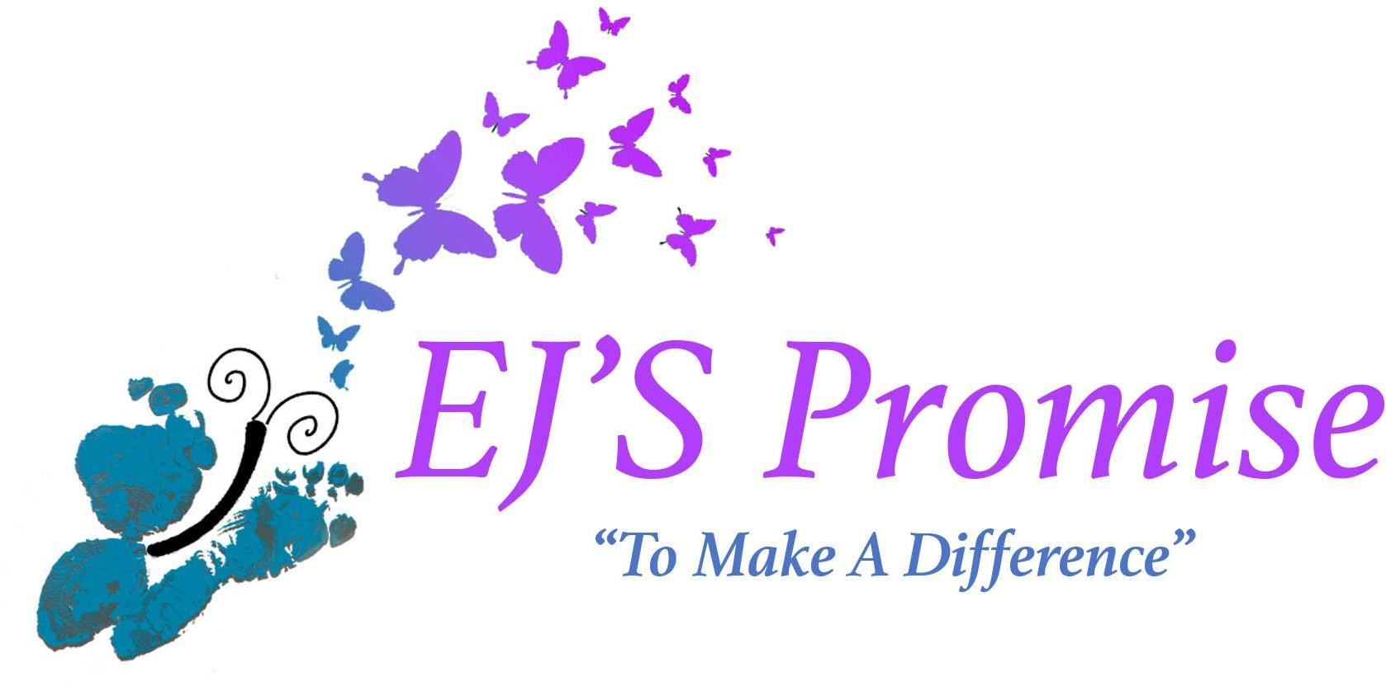

EJ’S PROMISE, Inc

117 Stearns Ave

Wyoming, Ohio 45215

Dear Valued Business & Friends,

EJ'S Promise's annual fundraiser-Putting Fore A Cause on August 3, 2024,will bring in over 150 attendees to enjoy a fun putting tournament and dinner afterward. This year's charitable event will raise funds for our two local organizations: Huntington's Disease Society of America, Ohio Valley Chapter (HDSA) and Cincinnati Children's Hospital Medical Center (CCHMC)- StarShine Hospice Program. Funds raised will be used to help support those who are facing debilitating, life-limiting and terminal illnesses – and their families.

Since 2019, our first Putting Fore A Cause, we have been able to raise just over $130,000! All proceeds have been evenly split between HDSA & CCHMC-StarShine Hospice Program.Your support and compassion allows StarShine and Huntington’s Disease Society to better care for and provide services to patients so they can make the most of their time spent with loved ones.

To help reach our goal of $50,000 this year, we need to limit event expenses. We're contacting our local hometown businesses, generous friends and family to request sponsorships at varying levels to help us fund this exciting charitable event.

* Gold Sponsor
* Silver Sponsor
* Bronze Sponsor
* Beer Cart Sponsor
* Hole Sponsor

We hope you will consider partnering with EJ’S Promise, together we can make a difference to support those in their time of need! Please see our attached brochure for all sponsorship information and benefits to your company.

We are a 501(c)3 non profit incorporated in Ohio. Tax ID #84-1978400. Please contact us at

513-616-2450/Karen or email [ejspromise@gmail.com.](mailto:ejspromise@gmail.com) You can also check us out at [www.ejspromise.org.](http://www.ejspromise.org/)

I am happy to discuss this opportunity over the phone or in person, whichever you prefer. Your generosity is greatly appreciated!

Darrell Sams, Karen Sams, Elizabeth Simon and Steve Simon

Administrators

EJ’S Promise Inc.

